**P530/2**

**BIOLOGY**

(Theory)

**Paper 2**

**2023**

2 ½ Hours

**Uganda Advanced Certificate of Education**

BIOLOGY

(THEORY)

**Paper 2**

2 hours 30 minutes

**INSTRUCTIONS TO CANDIDATES:**

*This paper consists of two sections,* **A***and* **B***.*

*Answer question* **one***in section* **A** *and any* **three***other questions in section* **B***.*

*Candidates are advised to read the questions carefully, organize their answers and present them precisely and logically, illustrating with well labeled diagrams where necessary.*

**SECTION A (40 MARKS)**

*Question***1** *is* **compulsory**

1. Thebelow shows the number of photoreceptor cells (types A and B) in the human retina along a horizontal line from the nasal side of the eye to the outside.

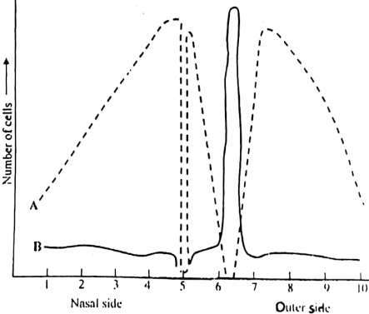

**Fig. 1**

1. Identify the types of photoreceptor cells represented by A and B.  *( 02 marks)*
2. Compare the number of cells of type A and B across the retina  *(08 marks)*
3. Explain the distribution of both types of receptor cells in the retina. *(10 marks)*
4. What is the name of the retina at position 6  *(01 mark)*
5. Explain why
6. the greatest concentration of receptor cells of type B occurs at 6 *(05 marks)*
7. there are no receptor cells at position 5 *(04 marks)*
8. Suggest changes that would happen in the human eye when a person moves from a bright surrounding into a dimly lit room

*(06 marks)*

1. Explain why in a dimly lit room objects are only visible in black and white. *(04 marks)*

**SECTION B (60 MARKS)**

*Answer any* **three** *questions from this section.*

*Any additional question(s) answered will* **not** *be marked.*

1. (a) Describe the structure of triglycerides. *(06 marks)*

(b) Explain the functions of lipids in the bodies of organisms. *(14 marks)*

3. (a) Describe the different mechanisms by which the human body prevent loss of blood.

*(08 marks)*

(b) How is Bohr Effect involved in transportation and exchange of respiratory gases.

1. *marks)*
2. (a) Describe the mechanisms which limit inbreeding in flowering plants *(10 marks)*

(b) Explain why:

1. In dioecious plants, male plants are usually associated with dry soils while female plants are associated with moist soils. *(02 marks)*
2. Dioecious plants are rarer than monoecious plants. *(02 marks)*

(c) What are the advantages of propagation by seeds? *(06 marks)*

1. (a) Explain the necessity of thermoregulation living organisms *(04 marks)*

(b) Describe strategies exhibited by the following organisms to survive low temperature conditions:

(i) Plants *(08 marks)*

(ii) Arctic animals *(08 marks)*

1. (a) Distinguish endangered species from extinct species *(02 marks)*

(b) Describe factors leading to biodiversity loss.  *(08 marks)*

(c) Describe different ways of conserving biodiversity *(10 marks)*